Code:-

import matplotlib.pyplot as plt
import numpy as np
import librosa

audio_path1 = "/Users/nikhilbhanderi/Desktop/Experiment 3/Audio/Vande Mataram (Maa Tujhe Salaam)-(Mr-Jat.in).wav"
audio_path2 = "/Users/nikhilbhanderi/Desktop/Experiment 3/Audio/Vande Mataram Karaoke -HQ.wav"

signal1, sr1 = librosa.load(audio_path1, sr=None, duration=60)
signal2, sr2 = librosa.load(audio_path2, sr=None, duration=60)

min_len = min(len(signal1), len(signal2))
signal1 = signal1[:min_len]
signal2 = signal2[:min_len]

def cross_correlation(sig1, sig2):
return np.correlate(sig1, sig2, mode='full')

def autocorrelation(sig):
return np.correlate(sig, sig, mode='full')
cross_corr = cross_correlation(signal1, signal2)
auto_corr = autocorrelation(signal1)
lags_cross = np.arange(-len(signal1) + 1, len(signal2))
lags_auto = np.arange(-len(signal1) + 1, len(signal1))
plt.figure(figsize=(12, 6))

plt.subplot(2, 1, 1)
plt.plot(lags_cross, cross_corr, color='b')
plt.title("Cross-correlation (Audio1 vs Audio2)")
plt.xlabel("Lag")
plt.ylabel("Correlation")
plt.grid(True)

plt.subplot(2, 1, 2)
plt.plot(lags_auto, auto_corr, color='g')
plt.title("Autocorrelation (Audio1)")
plt.xlabel("Lag")
plt.ylabel("Correlation")

plt.grid(True)

plt.tight_layout()
plt.savefig("./Audio_Correlation.png")
print("File Saved at Audio_Correlation.png")
plt.show()

Output :-

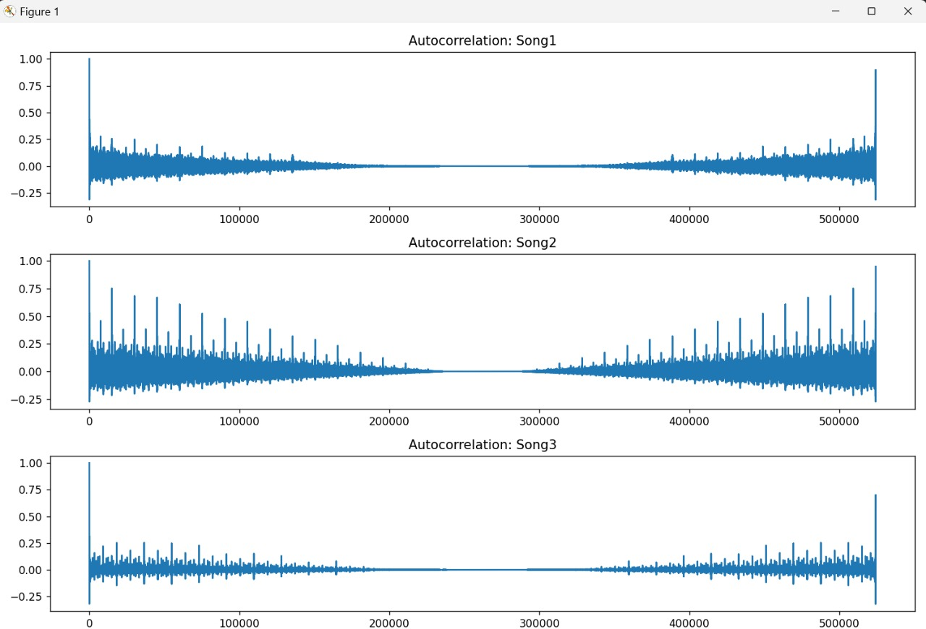

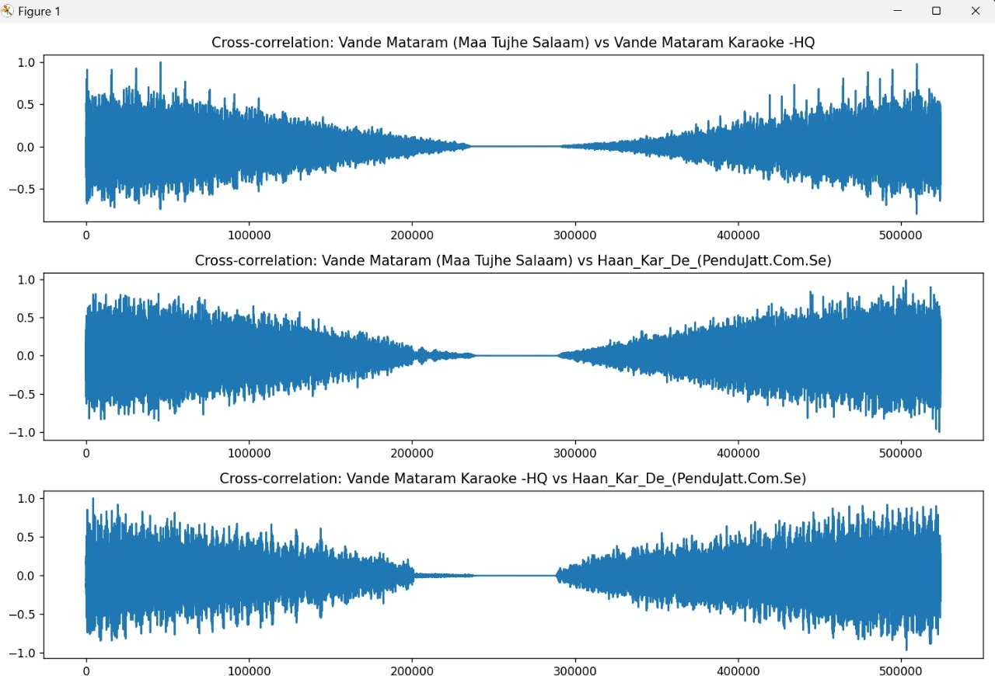
Observation:-

Observations:
- Cross-correlation (Audio1 vs Audio2):
  - The cross-correlation plot shows how similar the original audio and the karaoke version are at different time shifts (lags).
  - Peaks in the cross-correlation indicate points where the two audio signals are most aligned.
  - Since the karaoke track has the same instrumental and timing but no vocals, the cross-correlation is generally high where the instrumental parts match.
  - The maximum peak represents the best alignment or synchronization point between the two tracks.
  - The presence of multiple smaller peaks may indicate sections where rhythms or beats temporarily match.

- Autocorrelation (Audio1):
  - The autocorrelation plot shows the repeating patterns and periodicity within the original audio signal.
  - Peaks at regular intervals correspond to the rhythm or beat of the song.
  - The highest peak occurs at lag 0, which represents perfect self-similarity.
  - Other smaller peaks indicate repeating musical patterns or vocal phrases.
- General Insights:
  - Comparing cross-correlation with autocorrelation helps in understanding both alignment between two tracks and internal repetitive structure of the original track.
  - This analysis can be useful for audio synchronization, cover song detection, or vocal extraction tasks.
Conclusion:-

We learn this experiment cross-correlation shows similarity between two audio tracks, and autocorrelation reveals repeating patterns within a track.

